**Module 3 Assignment — Module Three Project   
Project: Forecasting Financial Time Series**

ALY-6050 Module Three Project

**Prepared by: Sarvesh Thorve**

**Email: throve.s@northeastern.edu**

# INTRODUCTION

We have an excel file which consists of the historical stock prices for Apple Inc (AAPL) and Honeywell International Inc (HON) for a total time period of one year, consisting of 252 market days. We are going to forcast the prices for the stock of both the companies using the short term, long term and regression method. This will help us making a decision as to which stock to invest in for the future and get better returns.

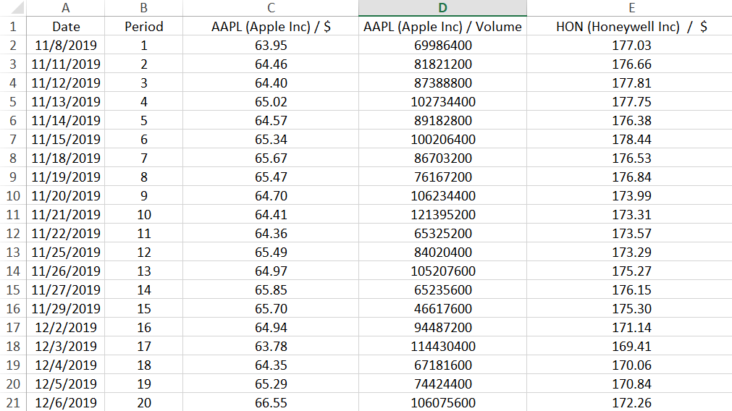

**PART 1:**

Simple line plot for Apple

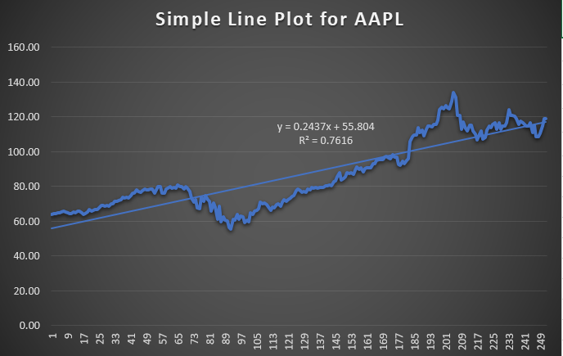

From the line plot above we can see that the stock prices for apple shows us an upward positive trend, this can see be seen from the line that indicates a trend which is positive.

Simple line plot for Honewell International

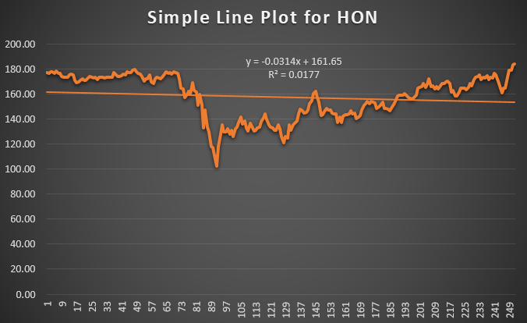

As we can see from the line plot above, the stock prices of the company Honeywell are having a slight downward irregular trend suggesting that the prices of their stocks are not very predictable and they keep on fluctuating on the basis of the period.

**ii)**

After performing exponential smoothing and finding successive values of   
0.15, 0,35, 0.55, and 0.75 for the smoothing parameter α to forecast both prices for period 253. We calculate the MAPD (Mean Absolute Percentage Deviation) of each forecast and based on the MAPDs we determine the value of α that has yielded the most accurate forecast for each stock.

So for Apple stocks we found out the alpha values of 0.75 with a MAPD of 2.26 percent seems to be the most accurate forecast for each stocks, it gives us accurate forecast and the least deviation so we go with the alpha value of 0.75.



So for Honeywell we found out the alpha values of 0.75 with a MAPD of 1.20 percent seems to be the most accurate forecast for each stocks, it gives us accurate forecast and the least deviation so we go with the alpha value of 0.75.

**iii)**

After using your exponential smoothing forecast of part (ii) with 𝜶=𝟎.55 and performing an adjusted exponential smoothing to forecast both prices for period 253. We use successive values of 0.15, 0.25, 0.45, and 0.85 for the trend parameters β for both stocks and then we calculate the MAPEs (Mean Absolute Percentage Error) of the forecasts and determine the values of β that have provided the most accurate forecasts for both stocks.

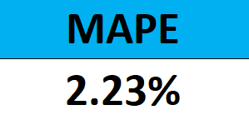So for Apple stocks we found out the β values of 0.45 with a MAPD of 2.23 percent seems to be the most accurate forecast for each stocks, it gives us accurate forecast and the least deviation so we go with the beta value of 0.45.

So for Honey well stocks we found out the β values of 0.85 with a MAPD of 2.12 percent seems to be the most accurate forecast for each stocks, it gives us accurate forecast and the least deviation so we go with the beta value of 0.85.

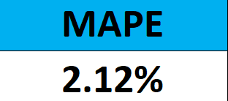

**PART 2:**

1. After calculating 3-period weighted moving averages to forecast its value during periods 1 through 100. We use the weights 0.5 (for the most recent period), 0.3 (for the period before the most recent), and 0.2 (for two periods ago). Next, we use the observed value for period 101 as the base of a linear trend, and use that linear trend to forecast the values of both stocks for periods 101 through 257.

We forecasted a few values from 253 to 257 based on the actual stock prices for both companies.

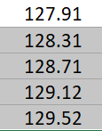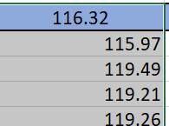For Apple we found out that the predicted or forecasted values were quite more than the actual stock prices, on those specific days they were not that close enough as we expected them to be.

Actual prices Predicted values

For Honeywell the predicted values which were forecasted seemed to be very low compared to the actual stock price, on those specific days they were not that close enough as we expected them to be.

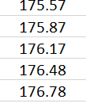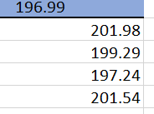

Actual Prices Forecasted prices

1. After calculating the MAPEs (Mean Absolute Percentage Error) of our forecasts in question (i) above, we compare those values with the values obtained for your forecasts in Part 1. We come to a conclusion that For each stock, the short term forecasting methods is the best fit to predict the values for the stocks. Short term forecasting gives us a very minimum deviation value which is the best fit for our prediction, leading to the best forecast.

**PART 3:**

Now we perform a residual analysis of our simple regression to verify whether regression is appropriate to use for each of the given data. In particular, determine:   
• Whether the residuals are independent   
• Whether the residuals are homoscedastic.   
• Whether the residuals are normally distributed by plotting a Normal probability plot of the residuals   
• Whether the residuals are normally distributed by performing a Chi-squared test for Normality of the residuals.

1. To check the independency of residuals for both the stocks there should not be any distinguishing pattern.

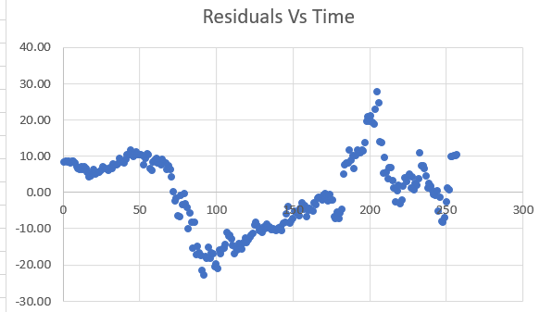

As we can see for Apple stock prices there are no distinguishing pattern so we can say that the residuals are independent.

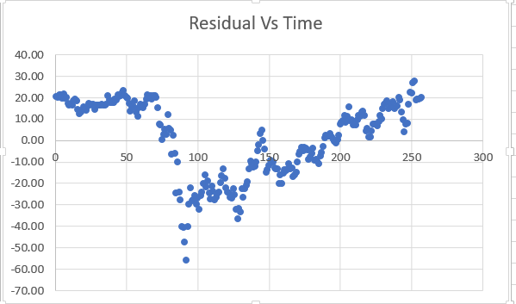

As we can see for Honeywell stock prices there are no distinguishing pattern so we can say that the residuals are independent.

1. To check the homoscedastic of residuals for both the stocks there should not be any distinguishing pattern.

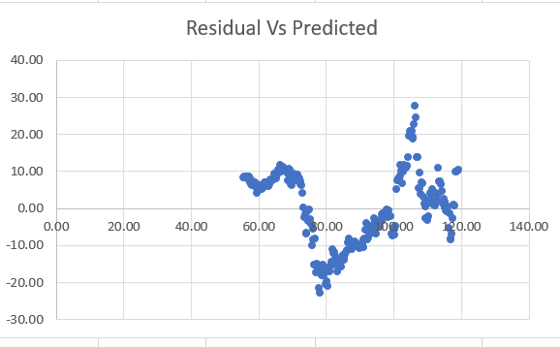

As we can see the residuals for Apple do not show any distinguishing pattern in the scatter plot therefore we can say that the residuals are homoscedastic.

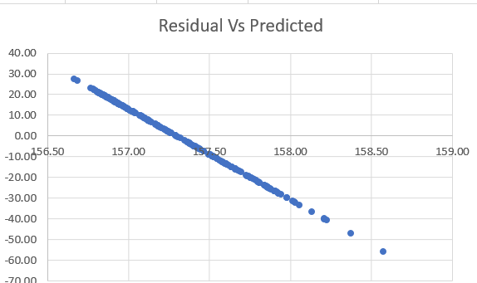

As we can see the residuals for Honeywell do show a distinguishing pattern which is a downward trend in the scatter plot therefore we can say that the residuals are not homoscedastic.

1. Now we check whether our residuals are normally distributed by plotting a normal probability plot of residuals.

For Apple INC:

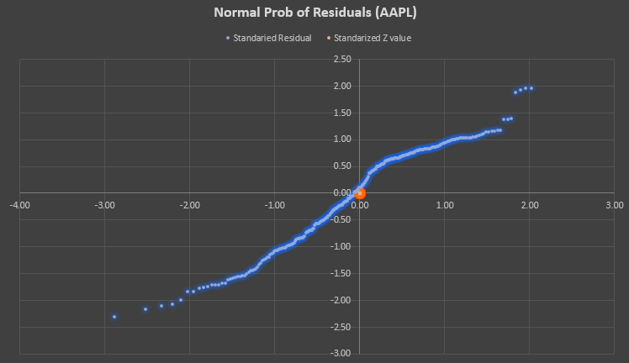

From this plot we can see that there is not much of a difference from the actual values. The line is almost a straight line indicating that the residuals are normally distributed.

For Honeywell INC:

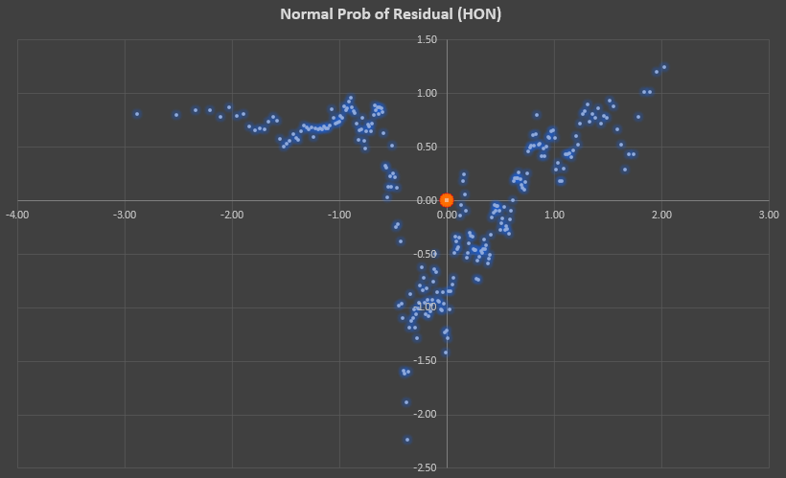

This plot tells us that the values are very scattered and are not close to the actual values. It does not resemble or show any sign of normality, therefore we can say that the residuals are not normally distributed.

We check it again by performing the Chi square test:

H0: The residuals are normally distributed

H1: The residuals are not normally distributed

Alpha = 0.05

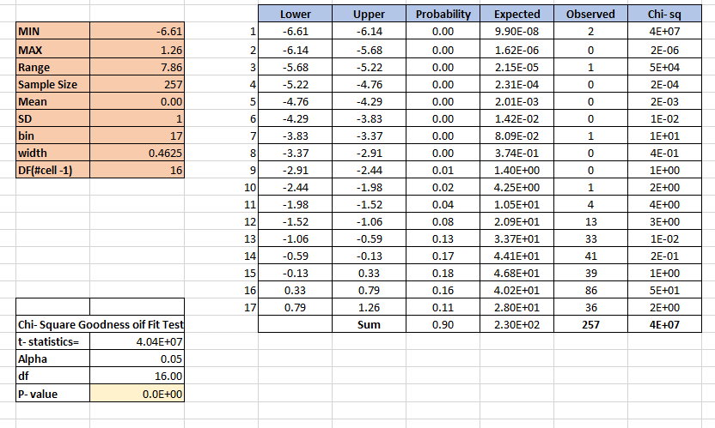

This test result gives us the chi square values along with minimum, maximum, Standard deviation, t statistics and the p value.

We can conclude from this test that the p value for this test is much lesser than the significance level of our test, concluding that we have to reject the null hypothesis in this case. Therefore we come to a conclusion that the residuals are not normally distributed.

Q)

A-> From the results and observations we got, I would definitely build my portfolio with 70% Apple stocks as they have proved to better in forecasting the value. Their stocks price residuals are normally distributed, which makes them easy to predict with lesser errors. The apple stock prices also shows a promising upward trend which is better for investing and making profits.

The remaining 30% of my portfolio would be for Honeywell, the prices are very hard forecast due to the variability in these stock prices. Their residual are also not normally distributed, the stock prices also show a stagnant downward trend in them which tells us not to risk the money as the risk to reward ratio is very less in the case of the Honeywell stock.

**REFERENCES:**

* *Regression Analysis*. (n.d.). Retrieved from https://northeastern.instructure.com/courses/97774/pages/lesson-3-3-regression-analysis?module_item_id=6650402
* *TIME SERIES ANALYSIS AND FORECASTING IN EXCEL WITH EXAMPLES*. (n.d.). Retrieved from Excel Table: https://exceltable.com/en/analyses-reports/time-series-analysis
* *What is the Chi-Square Test?* (n.d.). Retrieved from Alchemer: https://www.alchemer.com/resources/blog/introduction-to-chi-square-test-and-when-to-use-it/#:~:text=The%20Chi%2DSquare%20test%20is,all%20people%20in%20the%20U.S.